2.2 Decomposition Description

This section is a description of the classes and functions that make up the subsystems of the Quick Grad Planner as depicted in Figure 1.1. Figure 2.2.1 depicts in further detail the functional decomposition. Figure 2.2.2 is the class diagram for the Quick Grad Planner.

The Main Driver of the Quick Grad Planner will either create a new student record via the function new, or retrieve a student record via the function getStudentRecord. The student can modify, view, or print their Graduation Plan. Modify functionality is comprised of adding, modifying, and deleting semesters. When modifying a semester the student can add or delete courses. View functionality is comprised of viewing a range of semesters or either the courses requirements remaining in the Graduation Plan or the specific information about a course. The Quick Grad Planner can either print a range of semesters specified by the student or print the entire plan.

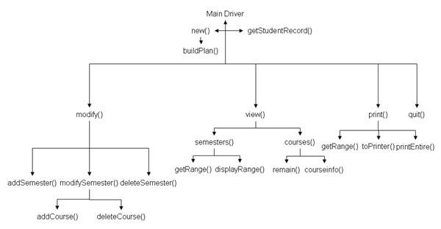
Figure 2.2.1 Functional Decomposition Diagram

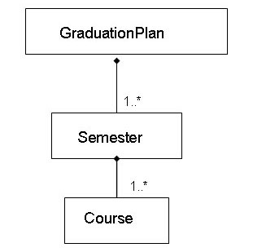
Figure 2.2.2 Quick Grad Planner Class Diagram

The New Plan Subsystem requests a blank GraduationPlan and sends this to the Main Driver to retrieve the User Data so as to build up Student Data. The Manage Plan Subsystem interfaces with the current GraduationPlan and Student as defined in the Student Data Repository. The View Plan Subsystem requests Semesters and Courses from the GraduationPlan. It requests Semester when displaying stored semester information, and it requests courses to display the remaining requirements. The Print Plan Subsystem receives a range of Semesters from the Main Driver and then requests them from the GraduationPlan. A GraduationPlan class contains 1 or more Semester classes. A Semester class contains 1 or more Courses.

Course Class – this class contains all data pertaining to a course, to include but not limited to its prerequisites, title, and description.

Course
int number
string title
string designator
string comments
char grade
vector<Course> prereqs or vector<int>?
+getNumber(): int
+getTitle(): string
+getDesg(): string
+getComments(): string
+inputnewGrade(): char
+inputComments(…): void

Semester Class – this class contains the Courses as Student has taken together in an academic semester. Semesters have a designator which is FL for Fall, WI for Winter, SP for Spring, and SU for Summer.

Semester
vector<Course> courses
string designator
int year
+viewCourse(): Course
+deleteCourse(): String
+addCourse(): String

GraduationPlan Class – this class contains all the Semesters a Student entered into the system as well as a Semester designated: startingSemester; indicating where to begin data range. The GraduationPlan Class also contains Student Data such as the student’s major.

GraduationPlan
string studentName
Semester startingSemester
string major
vector<Semester> plan
+printGradPlan(): void
+viewGradPlan(): void
+modifyGradPlan(): void
-addsemester(): void
-deletesemester(): void

